The syntax of navbars has changed a little bit from Bootstrap 3, what’s new is that they are built with Flexbox behind the scene, which means we can move elements around using the Flexbox utilities we learned so far.

Other than that Bootstrap 4 uses separate classes for *.nav*s, *.nav-item*s, and *.nav-link*s instead of HTML-specific selectors such like *.nav > li > a*. now instead of setting up that special structure we have to special classes.

Now we are going to see how we can use Flex utilities to move things around.

*<div= “container”>*

*<h1 class= “text-center display-4”>Navs+Flex</h1>*

*<ul class= “nav”>*

*<li class= “nav-item”>*

*<a class= “nav-link active” href= “#”>Active</a>*

*</li>*

*<li class= “nav-item”>*

*<a class= “nav-link” href= “#”>Link</a>*

*</li>*

*<li class= “nav-item”>*

*<a class= “nav-link” href= “#”>Link</a>*

*</li>*

*<li class= “nav-item”>*

*<a class= “nav-link disabled” href= “#”>Disabled</a>*

*</li>*

*</ul>*

*</div>*

*Output:*

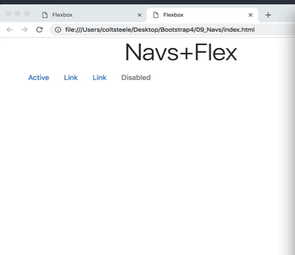

*<div= “container”>*

*<h1 class= “text-center display-4”>Navs+Flex</h1>*

*<ul class= “nav”>*

*<li class= “nav-item”>*

*<a class= “nav-link active” href= “#”>Active</a>*

*</li>*

*<li class= “nav-item”>*

*<a class= “nav-link” href= “#”>Link</a>*

*</li>*

*<li class= “nav-item”>*

*<a class= “nav-link” href= “#”>Link</a>*

*</li>*

*<li class= “nav-item”>*

*<a class= “nav-link disabled” href= “#”>Disabled</a>*

*</li>*

*</ul>*

*<nav class= “nav”>*

*<a class= “nav-link active” href= “#”>Active</a>*

*<a class= “nav-link” href= “#”>Link</a>*

*<a class= “nav-link” href= “#”>Link</a>*

*<a class= “nav-link disabled” href= “#”>Disabled</a>*

*</nav>*

*</div>*

*Output:*

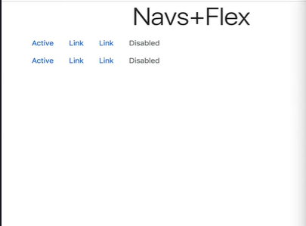

On the Bootstrap 4 website its mentioned that nav are now built-in with Flexbox. What that means is that that they have *display* set to Flex.

*<div= “container”>*

*<h1 class= “text-center display-4”>Navs+Flex</h1>*

*<ul class= “nav border border-primary”>*

*<li class= “nav-item”>*

*<a class= “nav-link active” href= “#”>Active</a>*

*</li>*

*<li class= “nav-item”>*

*<a class= “nav-link” href= “#”>Link</a>*

*</li>*

*<li class= “nav-item”>*

*<a class= “nav-link” href= “#”>Link</a>*

*</li>*

*<li class= “nav-item”>*

*<a class= “nav-link disabled” href= “#”>Disabled</a>*

*</li>*

*</ul>*

*</div>*

*Output:*

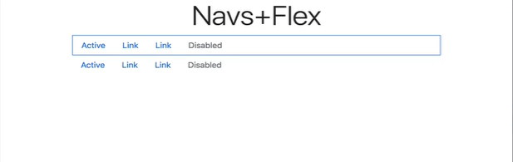

*<div= “container”>*

*<h1 class= “text-center display-4”>Navs+Flex</h1>*

*<ul class= “nav border border-primary* ***justify-content-end****”>*

*<li class= “nav-item”>*

*<a class= “nav-link active” href= “#”>Active</a>*

*</li>*

*<li class= “nav-item”>*

*<a class= “nav-link” href= “#”>Link</a>*

*</li>*

*<li class= “nav-item”>*

*<a class= “nav-link” href= “#”>Link</a>*

*</li>*

*<li class= “nav-item”>*

*<a class= “nav-link disabled” href= “#”>Disabled</a>*

*</li>*

*</ul>*

*</div>*

*Output:*

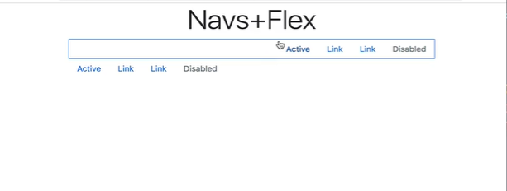

Notice that we did not have to mention display flex or *d-flex* before declaring the class justify-content-end because its already enabled by default on a nav, now if we were working with a div or something, we had to specify to make it flexbox by declaring *d-flex.* But Bootstrap 4 has already done that for us, when we declared the *nav* class, its already Flexbox enabled. So, we can move things around without declaring the display flex (*d-flex*) class.

*<div= “container”>*

*<h1 class= “text-center display-4”>Navs+Flex</h1>*

*<ul class= “nav border border-primary* ***justify-content-center****”>*

*<li class= “nav-item”>*

*<a class= “nav-link active” href= “#”>Active</a>*

*</li>*

*<li class= “nav-item”>*

*<a class= “nav-link” href= “#”>Link</a>*

*</li>*

*<li class= “nav-item”>*

*<a class= “nav-link” href= “#”>Link</a>*

*</li>*

*<li class= “nav-item”>*

*<a class= “nav-link disabled” href= “#”>Disabled</a>*

*</li>*

*</ul>*

*</div>*

*Output*

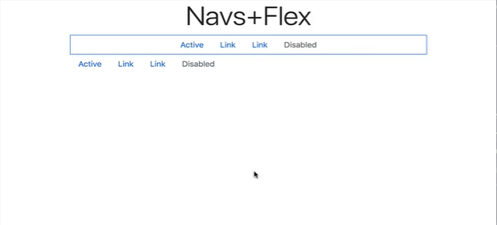

*<div= “container”>*

*<h1 class= “text-center display-4”>Navs+Flex</h1>*

*<ul class= “nav border border-primary* ***justify-content-between****”>*

*<li class= “nav-item”>*

*<a class= “nav-link active” href= “#”>Active</a>*

*</li>*

*<li class= “nav-item”>*

*<a class= “nav-link” href= “#”>Link</a>*

*</li>*

*<li class= “nav-item”>*

*<a class= “nav-link” href= “#”>Link</a>*

*</li>*

*<li class= “nav-item”>*

*<a class= “nav-link disabled” href= “#”>Disabled</a>*

*</li>*

*</ul>*

*</div>*

*Output:*

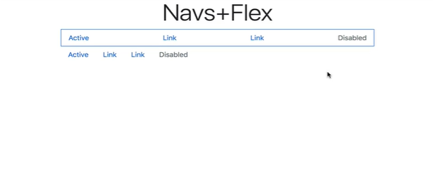

*<div= “container”>*

*<h1 class= “text-center display-4”>Navs+Flex</h1>*

*<ul class= “nav border border-primary* ***justify-content-around****”>*

*<li class= “nav-item”>*

*<a class= “nav-link active” href= “#”>Active</a>*

*</li>*

*<li class= “nav-item”>*

*<a class= “nav-link” href= “#”>Link</a>*

*</li>*

*<li class= “nav-item”>*

*<a class= “nav-link” href= “#”>Link</a>*

*</li>*

*<li class= “nav-item”>*

*<a class= “nav-link disabled” href= “#”>Disabled</a>*

*</li>*

*</ul>*

*</div>*

*Output*

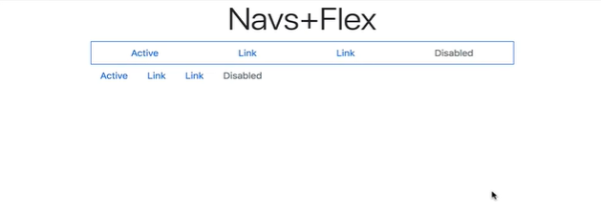

*<nav class= “nav* ***flex-column****”>*

*<a class= “nav-link active” href= “#”>Active</a>*

*<a class= “nav-link” href= “#”>Link</a>*

*<a class= “nav-link” href= “#”>Link</a>*

*<a class= “nav-link disabled” href= “#”>Disabled</a>*

*</nav>*

*Output:*

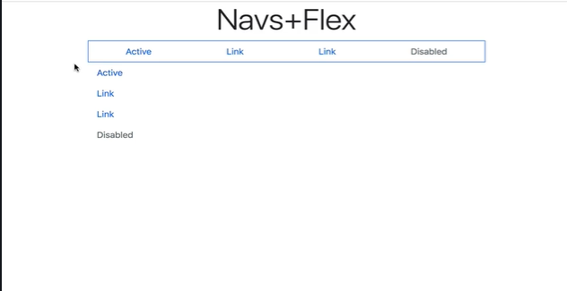

*<nav class= “nav* ***flex-column-reverse****”>*

*<a class= “nav-link active” href= “#”>Active</a>*

*<a class= “nav-link” href= “#”>Link</a>*

*<a class= “nav-link” href= “#”>Link</a>*

*<a class= “nav-link disabled” href= “#”>Disabled</a>*

*</nav>*

*Output:*

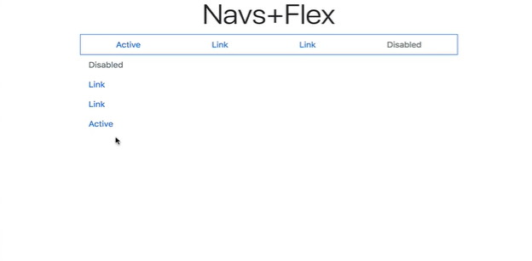

*<nav class= “nav* ***flex-column flex-sm-row****”>*

*<a class= “nav-link active” href= “#”>Active</a>*

*<a class= “nav-link” href= “#”>Link</a>*

*<a class= “nav-link” href= “#”>Link</a>*

*<a class= “nav-link disabled” href= “#”>Disabled</a>*

*</nav>*

*Output:*

*Extra Small screen*

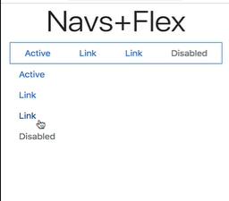

*Small screen*

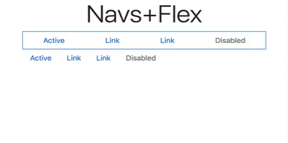

*<nav class= “nav* ***flex-column flex-sm-row justify-content-center align-items-center****”>*

*<a class= “nav-link active” href= “#”>Active</a>*

*<a class= “nav-link” href= “#”>Link</a>*

*<a class= “nav-link” href= “#”>Link</a>*

*<a class= “nav-link disabled” href= “#”>Disabled</a>*

*</nav>*

*Output:*

*Extra Small screen*

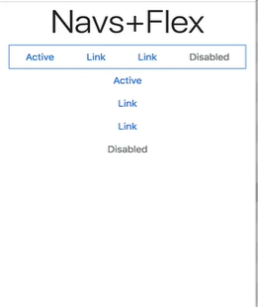

*On all other screens*

